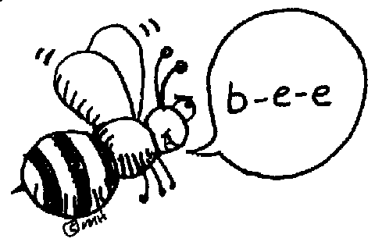
SPELLING CONTRACT

This spelling contract is a great way to study your spelling words! Choose up to 20 points worth of activities to complete this week. Always use your newest spelling words.

Name:
Please staple all work to your contract,
or get a parent signature if there is nothing to staple.
Check your choices: | # | Activity: | Point Value
 |  | Put the words in ABC order. | 5
 |  | Write each word three times. | 5
 |  | Make your words with magnetic letters. * | 5
 |  | Write the word and circle all of the vowels. | 5
 |  | Write the word and circle all of the consonants. | 5
 |  | Write the words neatly in pen. | 5
 |  | Complete all five spelling stations. Tally marks: _______ | 5
 |  | Draw pictures to help you remember each word. Write the word under each picture. | 10
 |  | Write sentences using the words. | 10
 |  | Write a synonym (another word that means the same) for each word. | 10
 |  | Write an antonym (a word that means the opposite) for each word. | 10
 |  | Scramble the words and give them to a friend to solve, or solve a friend’s scrambled words. | 10
 |  | Make a word search for your friend to solve, or solve a friend’s word search. | 10
 |  | Write your words neatly in cursive. | 10
 |  | Classify the words according to nouns, verbs, and adjectives. | 10
 |  | Type your words three times each. * | 15
 |  | Cut the letters of your words out of magazines or newspapers and glue them to a paper. | 15
 |  | Have someone give you a practice test of your words. * | 15
 |  | Jump rope with your words: each time you jump, say a letter of your word until you spell the whole word. * | 15
 |  | Play with your spelling words at this website:  http://teacher.scholastic.com/tools/spelling.htm | 15
 |  | Play spelling games to practice your words. (This says Lakewood Elementary, but they have the same words as us.)  http://www.spellingcity.com/lakewood3/ | 15
 |  | Write tongue twisters with the words. | 20
 |  | Write a story using the words. | 20
 |  | Complete a tic-tac-toe spelling contract. | 20
 |  | Create a word map for each of your words. | 20

